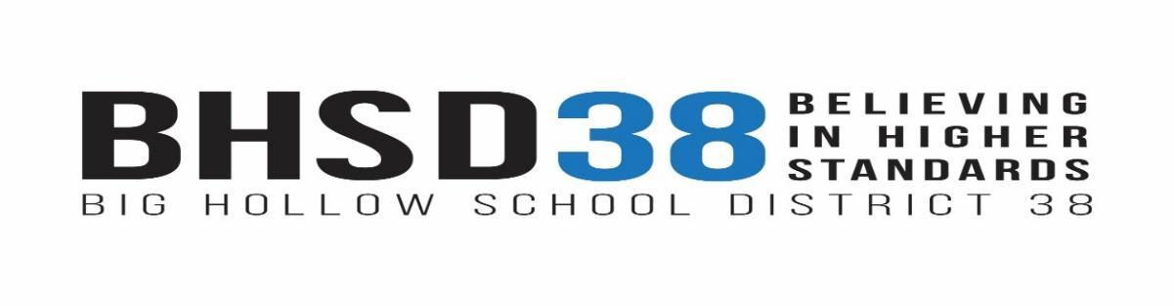
www.bighollow.us
Mr. Robert Gold, Superintendent

Big Hollow District Office  26051 W. Nippersink Rd.  Ingleside, IL 60041  Phone 847-740-1490  Fax 847-740-9172 | Big Hollow Primary School (EC-1)  33335 N. Fish Lake Rd.  Ingleside, IL 60041  Phone 847-740-5320  Fax 847-740-3490 | Big Hollow Elementary (2-4)  33315 N. Fish Lake Rd.  Ingleside, IL 60041  Phone 847-740-5321  Fax 847-740-3795 | Big Hollow Middle School (5-8)  26051 W. Nippersink Rd.  Ingleside, IL 60041  Phone 847-740-5322  Fax 847-740-9021

Public Notice Regarding Destruction of Records

June 1, 2022

Notice is hereby given that Big Hollow School District #38 intends to destroy the following records:

- Special Education temporary records 7/2015-6/2016

In accordance with the Illinois School Students Records Act and the Federal Family Educational Rights and Policy Act, temporary records for all students are maintained for five years after the student exits the school district. A permanent record of the student’s name, address, phone number, grades, attendance record and year completed is maintained for 60 years after the student has been withdrawn.

The purpose of destruction is to protect the student from improper and unauthorized disclosure of the confidential information contained within the file.

Any parent/guardian of a student under the age of 18, or former student who has reached 18 years of age, may review and/or receive records by contacting Jen Truss, Business Office Assistant by phone at (847) 740-1490 ext. 5046, by fax at (847) 740-9172, by email at jennifertruss@bighollow.us or written request to 26051 W. Nippersink Rd. Ingleside, IL 60041. A records release form will need to be completed. All requests must be made and received by June 24, 2022.

If no student, parent or guardian responds to this public notice, the school district will assume consent to destroy the records.

Robert B. Gold, Superintendent
Big Hollow School District #38

