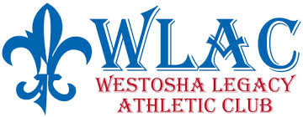
REGISTRATION FOR THE 2021 CHEERLEADING
Season is OPEN for 1st-8th Graders!
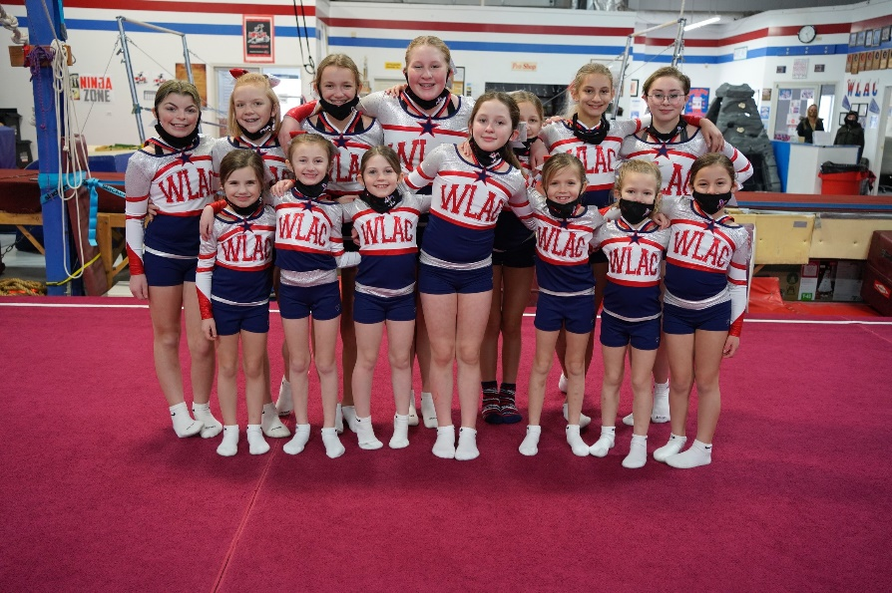
Congratulations to the WLAC CSUP3 and CSUP8 IRCA State Champions!
- Practices begin In July Monday and Thursday Evenings
- Saturday Practices Begin September 11th
- Monthly payments
- 3 competitions (plus state if Bid is earned)
- Stunting will return next season!
Please Contact WLAC for more information!
Phone: 815-675-3005 e-mail:wlacfrontdesk@gmail.com

