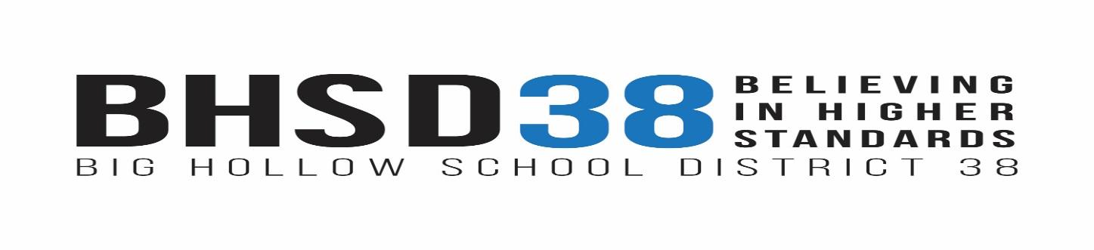
www.bighollow.us
Mr. Robert Gold, Superintendent

Big Hollow District Office  26051 W. Nippersink Rd.  Ingleside, IL 60041  Phone 847-740-1490  Fax 847-740-9172 | Big Hollow Primary School (EC-1)  33335 N. Fish Lake Rd.  Ingleside, IL 60041  Phone 847-740-5320  Fax 847-740-3490 | Big Hollow Elementary (2-4)  33315 N. Fish Lake Rd.  Ingleside, IL 60041  Phone 847-740-5321  Fax 847-740-3795 | Big Hollow Middle School (5-8)  26051 W. Nippersink Rd.  Ingleside, IL 60041  Phone 847-740-5322  Fax 847-740-9021
BHSD Parents/Guardians-
Tomorrow (Tuesday, Jan. 19th) will be a pretty exciting day at Big Hollow, as we welcome back so many of our students to in-person learning.
I feel like we have done everything we can at this point to prepare, but we can expect some bumps in the road in the coming weeks. Our administrators have taken many of our “normal” systems, pitched them out the window, and started over. The coming days our kids are going to experience school, but in many aspects it will look much differently than school has looked before.
To get this right, we are all going to need to work together. I just ask for your patience and your partnership in the coming weeks.
Here are some areas of emphasis that we all need to be aware of:
- Transportation has experienced the most change as we shift to this blended-hybrid schedule. There will be glitches in the first few days, but we will do everything we can to work them out. Our primary concern will be to make sure all students get to school and return home safely.
- Pick-up/drop-off traffic is somewhat of an unknown until we experience it these first few days. Please know that if there are problems, we will figure out solutions. We increased the bus capacity in hopes of decreasing the car traffic on campus. However, we still have busses that have capacity for more students.
- Our ability to keep the schools open will depend on our staffing capacity. If students/staff come to school with COVID-like symptoms, it could cause quarantine situations that will take adults out of our buildings. It is essential that you do not send your children to school unless you can confidently answer “NO” to the following questions:
  - Has your child experienced any COVID-19 symptoms in the past 48 hours?
  - Has your child been in close contact (in the past 14 days) with anyone who is known to have a confirmed case of COVID-19 or has symptoms consistent with COVID-19?
- We do have testing available for staff/students who display COVID-19 symptoms, and will have results within 15 minutes. We will not give a student a test without parent approval.
- We have installed over 100 hand sanitizing stations throughout each building. Encourage your children to use those stations often.
- Please review with your children how to properly wear their mask over their mouth and nose.
It has been 10 months since our schools resembled any sense of normalcy. Let’s hope the coming days will bring some solid steps in the right direction. As a community you have been incredible in understanding, as well as respectfully sharing your opinions with me. I thank you all for that!
Let’s hope for the best in the coming days :) Feel free to reach out to me if you have any questions.

Bob Gold
Superintendent
Big Hollow School District 38

