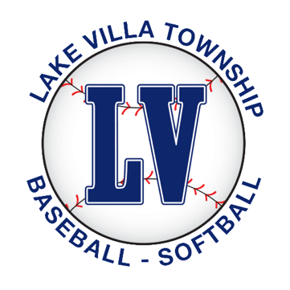

Registration for the upcoming spring baseball and softball season is now open.

LVTB offers baseball and softball leagues for more than 700 boys and girls between the ages of 5 and 14 within your school district. We are Lake County’s premier baseball and softball organization.

Our season begins with practices in April and games starting in May and running through the end of June. Don’t miss your opportunity to register!

With baseball season just around the corner, we encourage families to register ASAP to ensure your child’s spot within the league. We are also looking for parents that would like to coach or manage teams, which help our kids learn about the game and develop many important life skills.

To register, please visit www.lvtb.org today!

For more information on Lake Villa Township Baseball and Softball, email us at contact@lvtb.org
or visit our Facebook or Twitter page.

