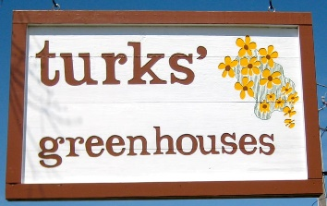
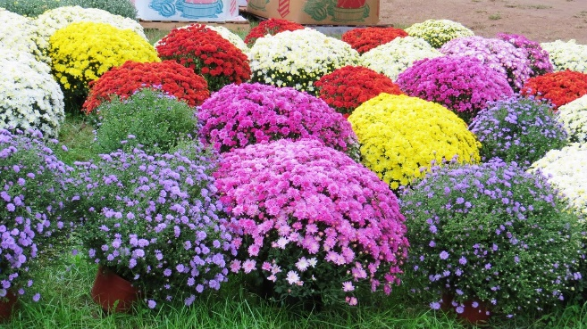
Get ready for a BIG beautiful fall with MUMS!
We are partnering with local nursery, Turks Greenhouse, to bring you BEAUTIFUL FALL MUMS!
These gorgeous 9inch mums come in Red, White, Purple/Lavender, Yellow and Orange and sell for $9 each.
$4 of that will be donated back to YOUR PTO to benefit ALL the kiddos, staff and families of Big Hollow!
Complete this order form and pay by cash or check. You can drop it off at any of the school offices in an envelope marked “BHPTO MUM SALE” or email cindyharan@bighollowpto.com
Orders and payments MUST be received by 11:59pm September 1st!
Mums will be available for pick up on Saturday, September 18th, 2021 from 830am-1pm during our Kids' Resale and Community Market!
Name: _________________________________________________
Cell & Email: _________________ __________________________________

MUMS $9 each Quantity
RED __________ Cash Amount enclosed _____________
White __________
Orange __________ Check Amount and # _______________
Purple/Lavender __________
Yellow __________

