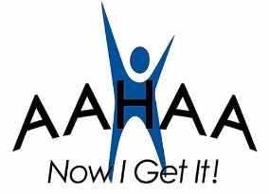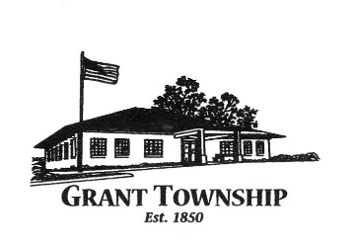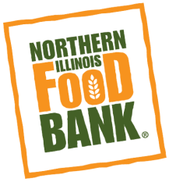

Sign up to volunteer at

[https://solvehungertoday.civicore.com/volunteercalendar](https://linkprotect.cudasvc.com/url?a=https://nam01.safelinks.protection.outlook.com/%3Furl%3Dhttps%253A%252F%252Flinkprotect.cudasvc.com%252Furl%253Fa%253Dhttps%253A%252F%252Fnam01.safelinks.protection.outlook.com%252F%25253Furl%25253Dhttps%2525253A%2525252F%2525252Fsolvehungertoday.civicore.com%2525252Fvolunteercalendar%252526data%25253D02%2525257C01%2525257C%2525257Caa6a9337d7ac4f32680e08d82a8f5617%2525257Cb1f9e34f11214c708f88aff49a1ef321%2525257C1%2525257C0%2525257C637306142404939619%252526sdata%25253D2jUctRLXQ%2525252FbNxL5ixwMe3wyKFmomZylRPfhNMqMaVyE%2525253D%252526reserved%25253D0%2526c%253DE%25252C10%25252CdYrpUx46cogLczEe4vFVBFi3jKjteFCmriYAp7WSwD8JNpVT6%252FsRswy40sJl0TcJgHSMRxr95sZ7BHIB%2526typo%253D1%2526know%253D0%26data%3D02%257C01%257C%257C32c373df52da4fb2218e08d82a92c563%257Cb1f9e34f11214c708f88aff49a1ef321%257C1%257C0%257C637306157173021840%26sdata%3DcnbgPuBlZxbNuGRwtVGXKeaAHjdcQoSor9NTN5aWzMk%253D%26reserved%3D0&c=E%2C10%2C3RMuyTNqaf4ZRta9BqjtD0FdvjTW3wl2am5AgMmDSe6Ksud1/SJsM36NvfESW9hxsFOaSSvaYJ5XysKi&typo=1&know=0)

**In Partnership with Lake County Officials &**

**Judy Martini – Lake County Board**

Saturday, October 3, 2020

9 a.m. – 12 p.m.

**Northern Illinois Food Bank** invites you to our drive-thru Pop-Up Market to pick up fresh groceries **Saturday, October 3, 2020 at Grant Community High School in Fox Lake.** Anyone in need of a little extra help during this time is welcome to join us.   
**No ID is needed.**

Grant Community High School

285 Grand Ave. Fox Lake, IL

(Enter off of Grand Ave.)

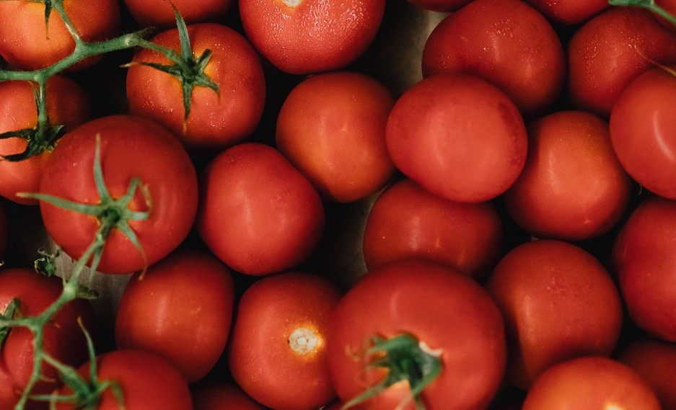

Pop-Up Market